5. Project Development Phase
5.1 Flow Creation:
The first development activity is creating the flow designer workflow
Navigate to:
All → Flow Designer → New → Flow
Create a flow with the following properties:
- Flow Name: Standard Laptop Task
- Application: Global
- Run as: System User
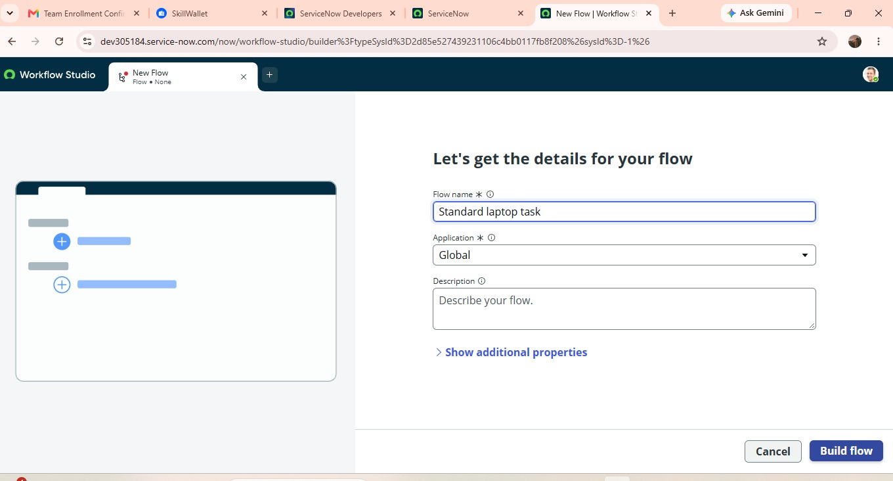
Fig: Creating Flow

5.2 Configure Trigger:
Select:
Trigger → Service Catalog
This allows the flow to work with service catalog requests.
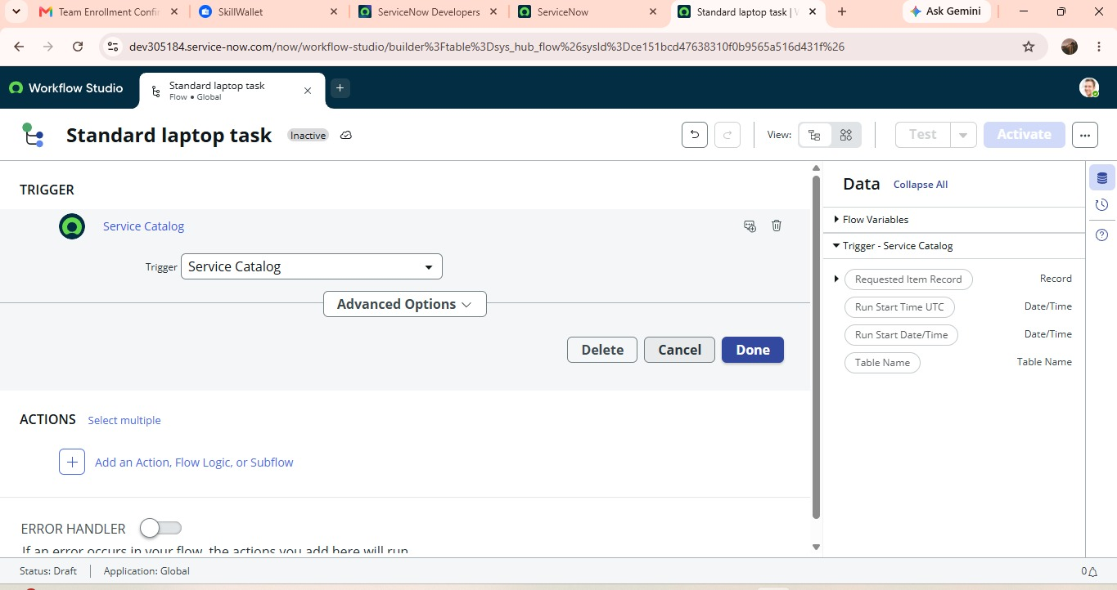
Fig: Service Catalog Trigger
5.3 Create Catalog Task:
Actions → Create catalog task
Configure the action using the requested item record. The required fields are configured as follows:
- Request Item: Request Item Record
- Short Description: Laptop need to configured
- Description: Laptop need to configured
- Assignment Group: hardware
- Approval: Approved
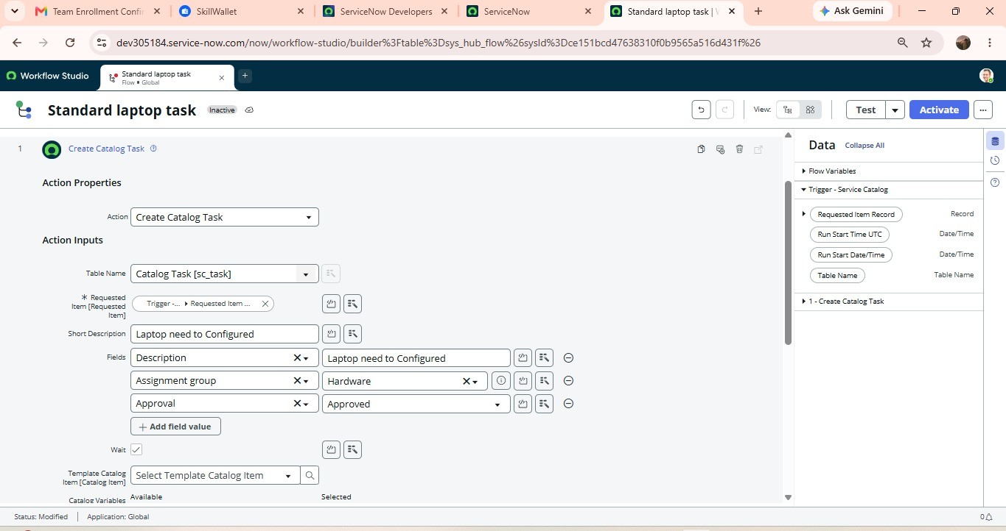Fig: Catalog Task Configuration
5.4 Save and Activate Flow:
After configuring the action:
- Click Done.
- Save the Flow.
- Click Activate.
- Confirm Activation.
The flow is now ready to be used by the standard laptop catalog item.
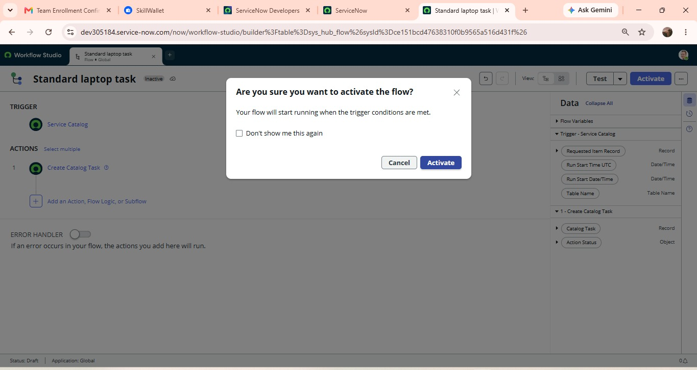
Fig: Activating Flow
5.5 Assign Flow to Standard Laptop:
Navigate to:
All → Maintain Items
Search For:
Standard Laptop
Open the standard laptop catalog item and navigate to Process engine. Remove unnecessary existing automation and add:
Standard Laptop Task
And save the record.
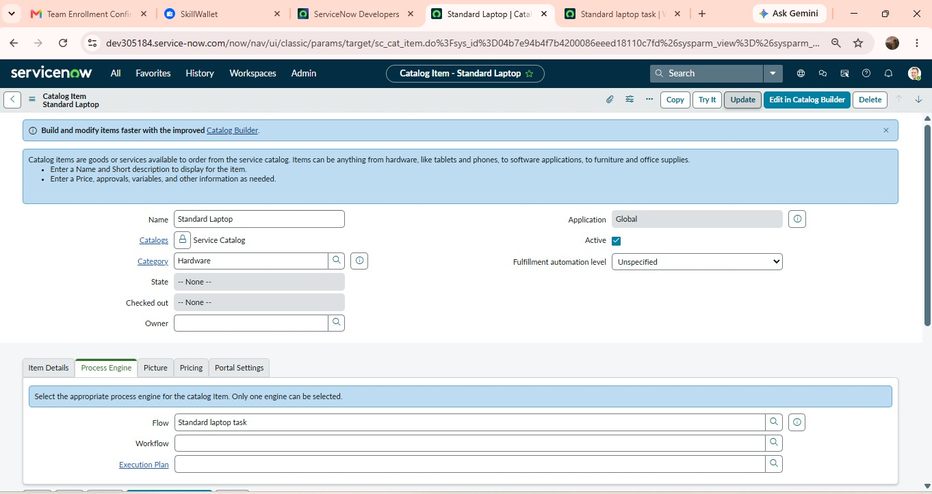
Fig: Process Engine section showing assigned flow

5.6 Test the Service Catalog:
Navigate To:
All → Service Catalog → Hardware → Standard Laptop
Select:
Order Now
Submit the request. After placing the order, open the request number and check the request details.
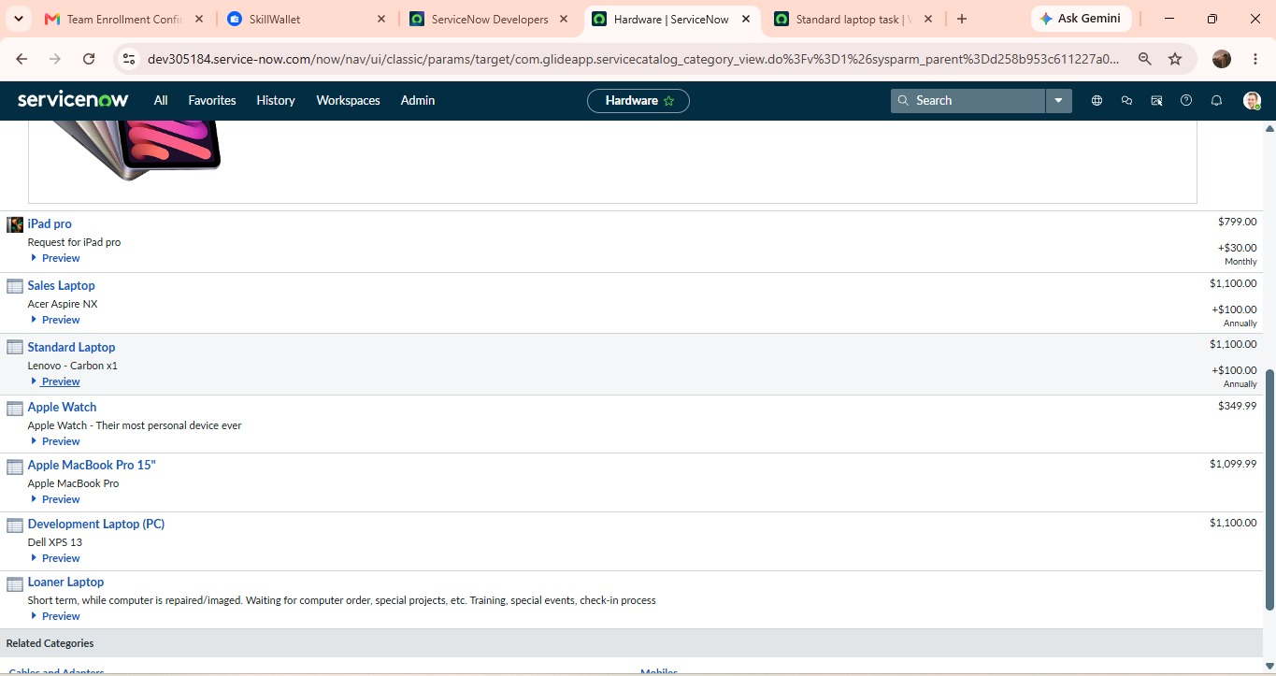Fig: Hardware category showing Standard Laptop
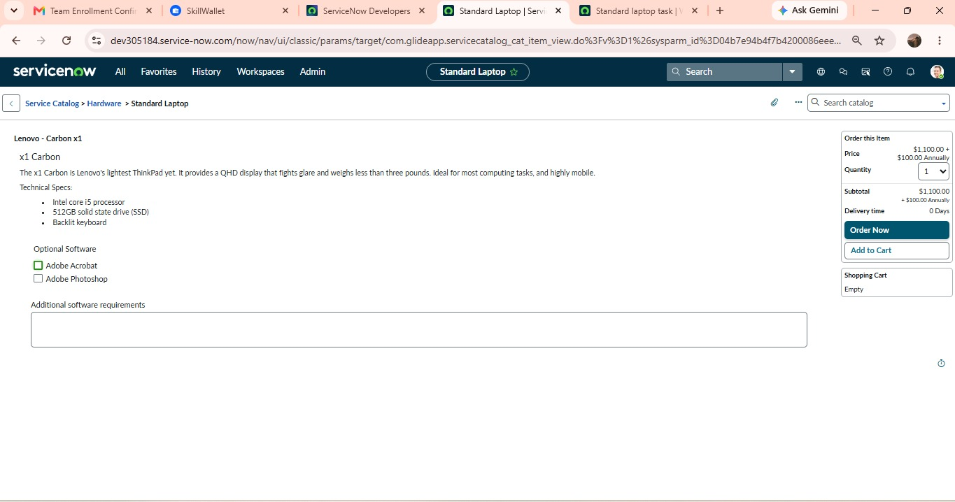Fig: Standard Catalog Item and Order Now Page.
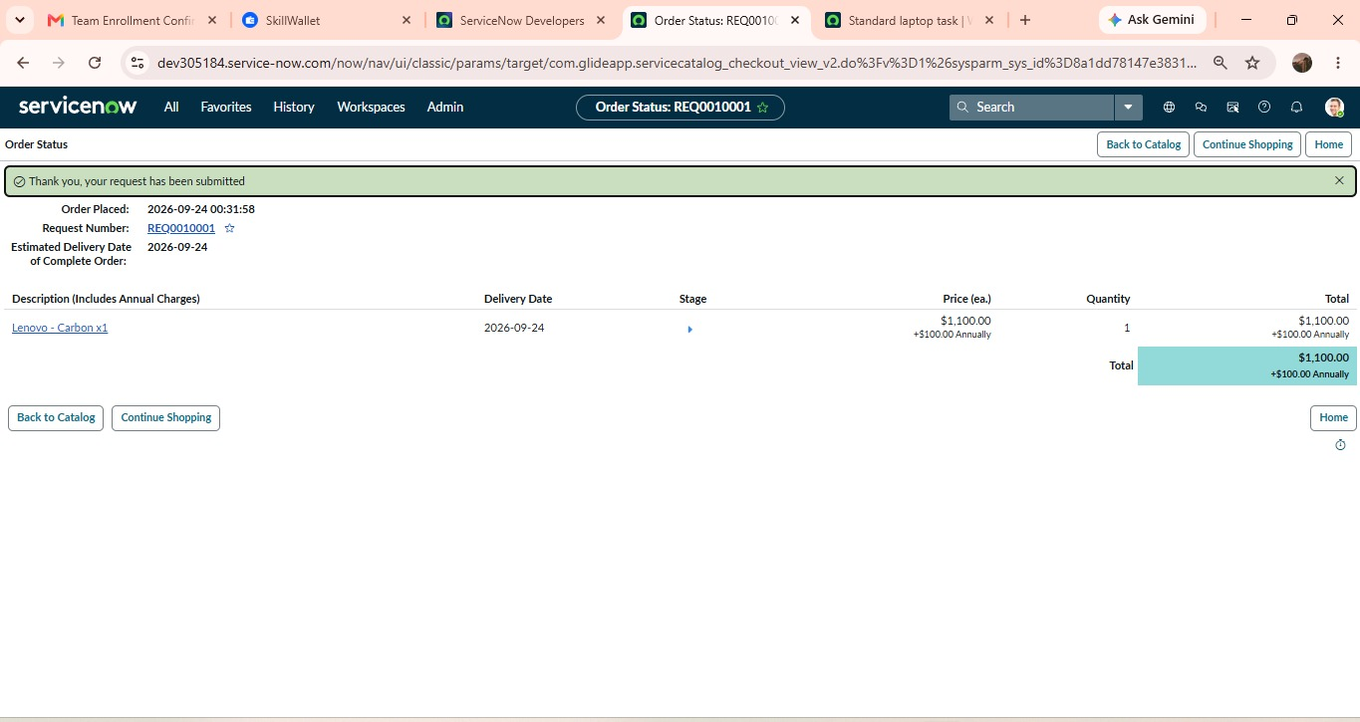Fig: Submitted Request
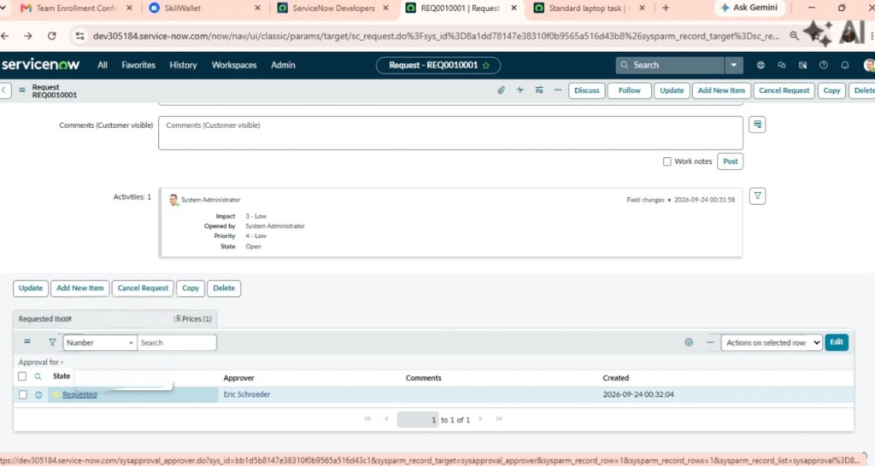
Fig: Requested Image.
5.7 Verify Approval:
Open the request and navigate to the approvers section and approve the request. After approval, open the Requested Item associated with the request.
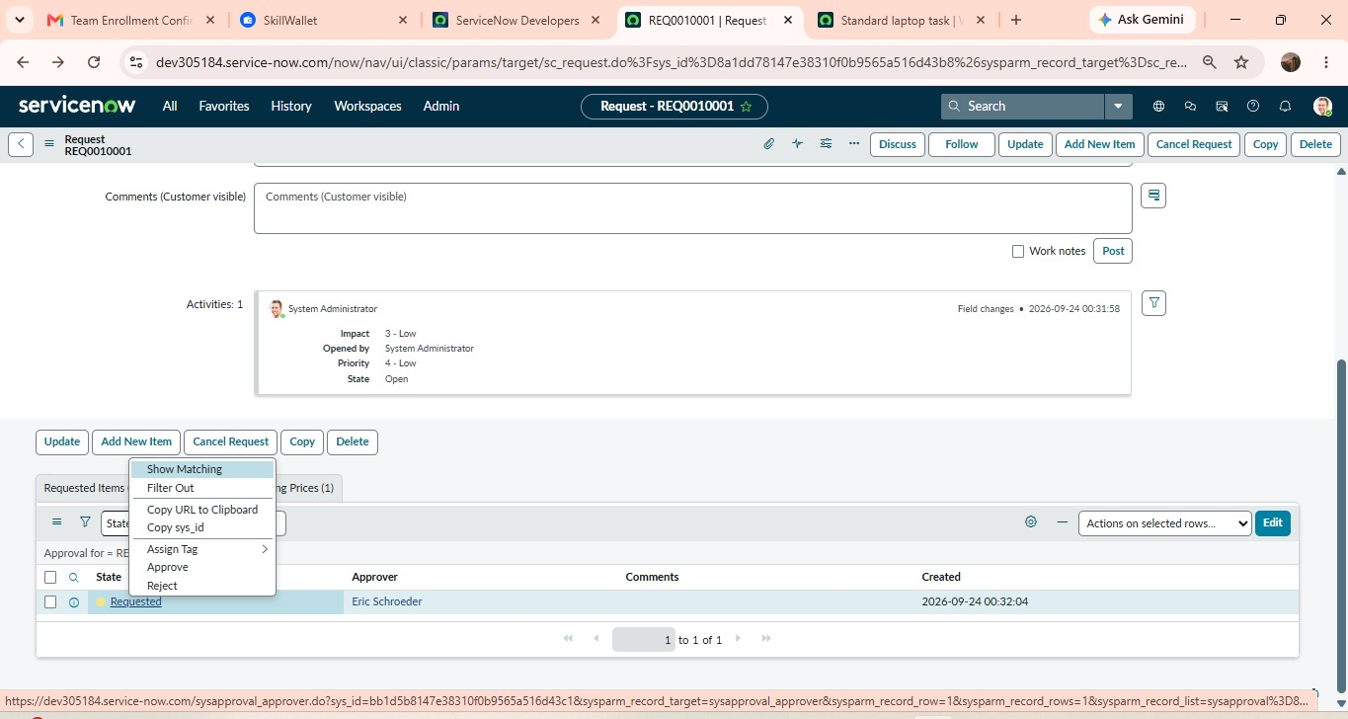Fig: Approvers Section
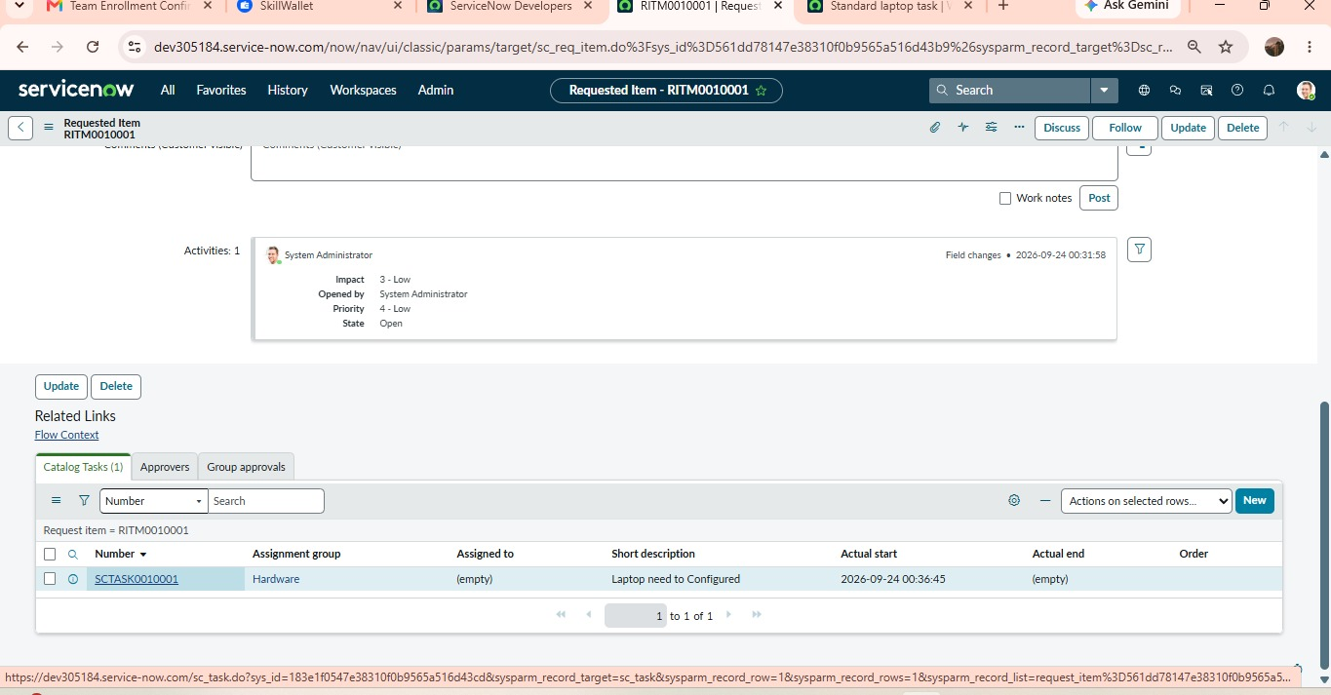Fig: Requested Item Record
5.8 Verify Catalog Task:
Scroll down to the Catalog Tasks section of the requested item. Open the generated catalog task. Verify that the flow has automatically populated the required information.

Expected Result:
Field | Expected Value
Short Description | Laptop need to configured
Description | Laptop need to configured
Assignment Group | Hardware
Approval | Approved

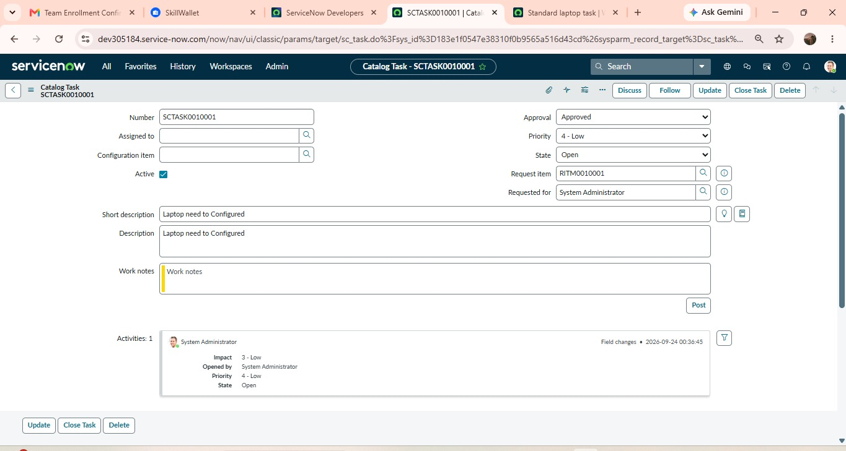Fig: Final Catalog Task

